Registered Charity Number 1073843

Minutes of the Annual General Meeting
(AGM)

Tuesday 16 November 2021
at 7.30pm in the Sports Pavilion

Attendance and Apologies for Absence
Chair – Amanda Rafferty* | P | President – Mr Cooksey (Headteacher) | A
Secretary – Joanne Hayden* | P | External Relations and Fundraising Coordinator - on behalf of school – Donna Connolly | P
Treasurer – Phil Mullen* | P
Phanishree Marthy* |  |  | P
Kathryn Bourke* |  |  | P
Rakshanda Hussain* |  |  | P
Nikita Mistry* |  |  | P
Malath Shaker* |  |  | P
Sital Patel* |  |  | P
Sam Hasan* |  |  | A
Jean Ryba* |  |  | A
Sarah Marshall |  |  | A
Adam Marshall |  |  | A
Key: *=Executive Committee/P=Present/A=Apologies

- Welcome and Apologies for Absence

Amanda welcomed and thanked everyone for attending. Attendance and apologies for absence are recorded above.

- Election of Officers for the Friends of School

According to the Rules of the Constitution, the Executive Committee can consist of up to 18 individuals, which must include a Chair, Treasurer and Secretary. Amanda Rafferty, Chair, stood down at the meeting and Rakshanda Hussain and Nikita Mistry were elected to the positions of Co-Chairs:

Co-Chair: Rakshanda Hussain Co-Chair: Nikita Mistry
Proposer – Joanne Hayden Proposer – Joanne Hayden
Seconder – Kathryn Bourke Seconder – Phanishree Marthy

According to the rules of the Constitution, the Secretary and Treasurer of the Executive Committee stood down at the meeting, and were re-elected:
/…
Secretary: Joanne Hayden Treasurer: Phil Mullen
Proposer - Kathryn Bourke Proposer - Phanishree Marthy
Seconder - Phanishree Marthy Seconder – Kathryn Bourke

Marianne Goodman stood down from the Executive Committee but will remain as a committed helper. The following members were re-elected (Proposed by Joanne Hayden and Seconded by Phil Mullen):

Jean Ryba
Kathryn Bourke
Phanishree Marthy (to stand down in mid-July)
Sivakumar Manokaran
Tapan Shill
Sam Hasan
Parag Pawar
Irena Voitkevic

The following members were newly elected to the Executive Committee:

Malath Shaker Sital Patel
Proposer – Phanishree Marthy Proposer – Phanishree Marthy
Seconder – Amanda Rafferty Seconder – Amanda Rafferty

In addition to the Executive Committee, the FoS has trustee activity for which there is a legal responsibility. Neil Shah has been removed as a trustee now that he has stood down from the role of Treasurer and Phil Mullen will replace him. Amanda Rafferty will be removed now that she has stood down as Chair and will be replaced by Rakshanda Hussain and Nikita Mistry. Kathryn Bourke and Jean Ryba remain as trustees. The FoS website will be amended to reflect the status of the trustees. Government guidance about the role of trustees can be found here.

Neil Shah has been removed as a bank account signatory and replaced by Phil Mullen. Amanda Rafferty will be replaced by Rakshanda Hussain and Nikita Mistry. Jean Ryba will remain as an account signatory.

- Rules and Constitution

The Rules and Constitution, approved in 1998, remain unchanged.

/…

- Chair’s Report for 2020-21
Amanda Rafferty – Chair, FoS
November 2021

Sadly, due to Covid restrictions, since my last Chair’s report in April 2021 we have still not been able to run many activities.

However, we did start the year with a really nice evening in September welcoming new parents to the school. Our Year 7 Parent Welcome Social was held in the foyer of the James Theatre and gave around 100 Year 7 parents an opportunity to meet and socialise with other new parents in a relaxed setting with a buffet and bar. We hope to shortly run a similar evening for Year 8 parents who missed out on this opportunity last year.

I was pleased to welcome earlier this year two new members to the Executive Committee in the “official” roles of Secretary and Treasurer. They have settled into their roles well and hopefully will provide the Friends with some stability after a few changes in these positions pre- and during Covid.

The second-hand uniform shop has continued to be a reliable source of income as well as a valuable service to parents. We now have a regular team of volunteers who open the shop each Wednesday after school and the first Saturday of each half-term. However, a couple more volunteers to help out on a rota basis would be really welcomed. If you are interested in helping out, please contact uniformshop@friedsofwbgs.org.

Another means of on-going fundraising is the Family Draw, our lottery-style draw taking place each term. We would love more families to take part in the Draw. It only costs £25 a year and you stand a chance of winning a cash prize each term. The more families who take part, the more money contributed to school funds, but also a greater termly prize! If you’d like to sign up, please email familydraw@friendsofwbgs.org.

As I write this report, we are about to run the annual Quiz night which I am looking forward to. It is always a fun evening and a good fundraiser – by moving it to this side of Christmas we hope it will kick-start the fundraising for this year after a difficult 18 months. We will also be running a bar and a raffle as usual at the Autumn Music Concerts later in November.

I am standing down at this November’s AGM after four years in the role. I have immensely enjoyed my time as Chair and, as well as feeling proud to have been part of a number of activities and events which have brought parents and students together and raised considerable funds for the school, it has also enabled me to fulfil my other own objective of meeting other parents and feeling much more a part of the school community. My role would not have been possible without the support and hard work of a small, but hugely dedicated team of volunteers and I would like to thank each and every one of you. Thank you also to everyone who has supported the events and activities we have organized – it can sometimes feel like an unenviable task, but the end result is always worth it.

I feel confident that the incoming Chairs, Rakshanda and Nikita, along with the support of both new and longer-standing Committee Members, will do a great job continuing the work of the Friends of School and I wish them the very best of luck.

Thank you and best wishes.

Amanda

/…

- Treasurer’s Report
Phil Mullen – Treasurer, FoS
November 2021 (a separate identical version is available)

Table 1
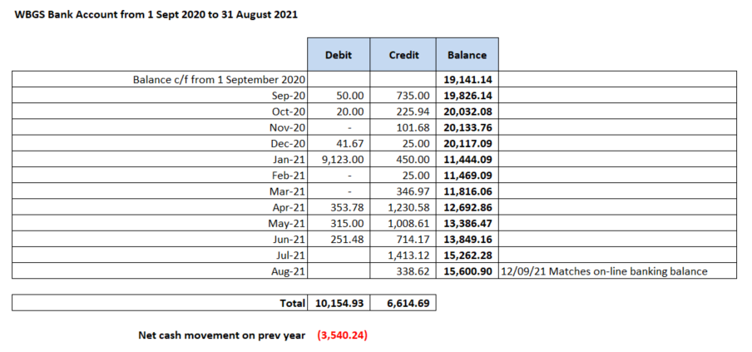

Table 2

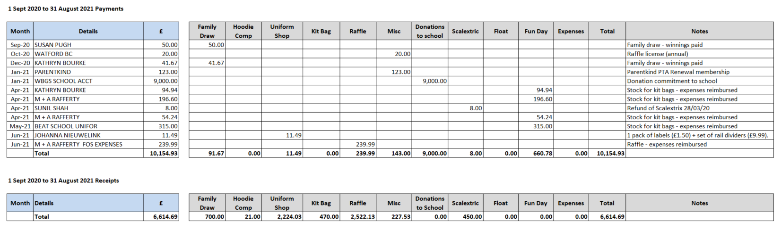

/…
Table 3

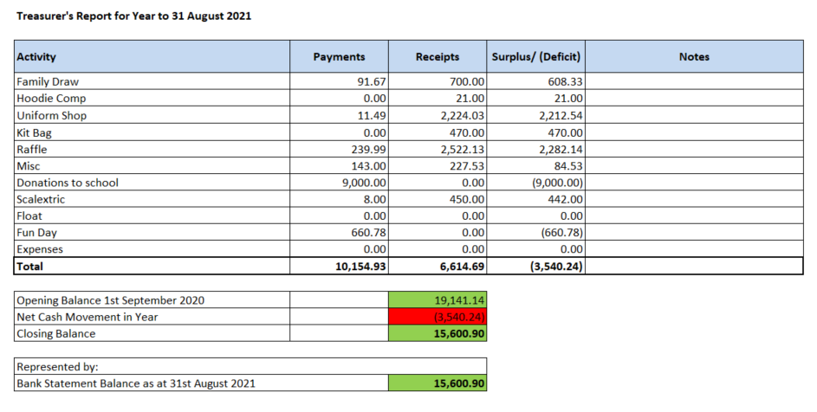

The bank account fully reconciles. Table 2 illustrates the impact of COVID on fundraising activity where fewer payments have been made than during a pre-COVID fundraising year. The largest fundraising activities have been the raffle and uniform shop. Other fundraising activity has been much smaller. Table 2 illustrates where a payment for £9K was made in January 2021 for the IT department (which pre-dates Phil’s time as Treasurer) and the annual FoS donation to the school. The debits and credits total the banking balance as of September for the start of the financial year. There was a total amount of £15,600.90 in the bank account at the end of August. Our net cash position is that we are £3,500 in cash movement down after paying the £9K. There were no objections to the 2020 accounts. The Treasurer’s Report was formally signed off by those present and will be submitted to the Charities’ Commission.

The balance of the bank account on 10 November was £16,481.91. Phil has removed three separate amounts of £150 to be used as separate floats for the Quiz Night on 20 January and the music concerts on 24 and 25 November. We have made payments for the Quiz Night to purchase stock and the bank account is currently showing no receipts although the Ticketsource payment will go through on Monday/Tuesday.

