The start of this half-term saw the return of the popular Comedy Night organised jointly with WGGS Parent Association. We were entertained by 3 professional comedians and our compere for the evening, and with the acts interspersed with short intervals everyone had an opportunity to catch up with friends over a drink and laughter. A big thank you to everyone who attended.
Baking MasterClass
Another popular event are our baking Masterclasses, kindly run by Mrs Zachariah in the school Food Tech department and the latest one of these took place in November when participants made a Meringue Roulade.
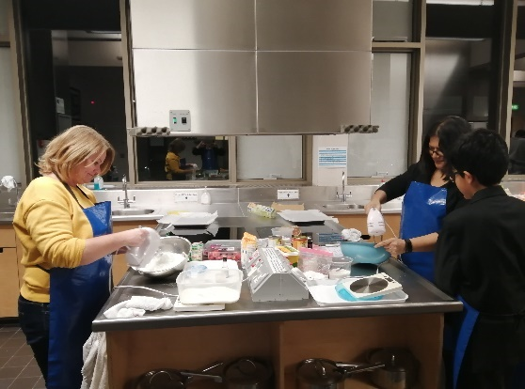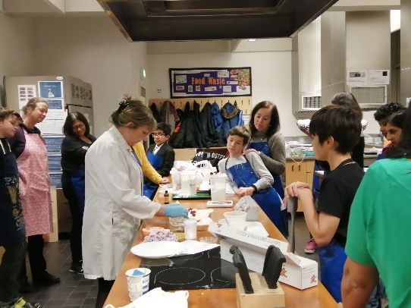
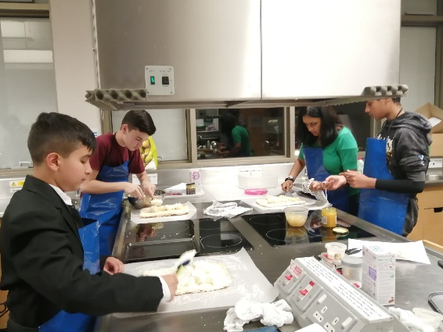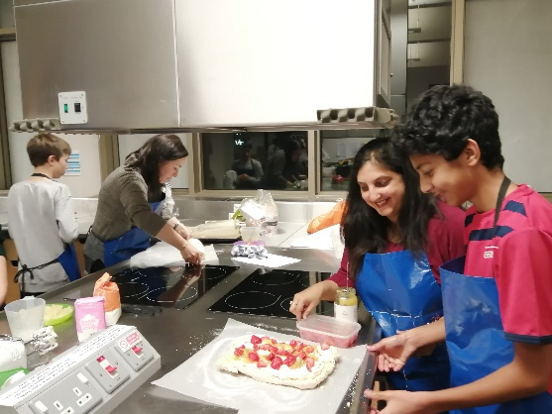

We plan to run another class in the Summer Term so look out for announcements nearer the time.
Christmas Pudding Stir-Up
Still on the baking theme and in line with our objective of bringing the school community together in addition to our fundraising activities, we held another new event: A Christmas Pudding Stir-Up. This was based on the tradition of Stir-Up Sunday where families come together to make and stir-up their Christmas pudding. A number of families took up the opportunity to come along to the STEM centre where they were provided with a recipe and all the ingredients to make either a traditional or vegan / alcohol-free pudding. Having spent an enjoyable hour mixing the puddings these were then taken home to be steamed ready for Christmas.
This was a really enjoyable evening in a relaxed, festive atmosphere and we were really pleased to see so many dads and children joining in.
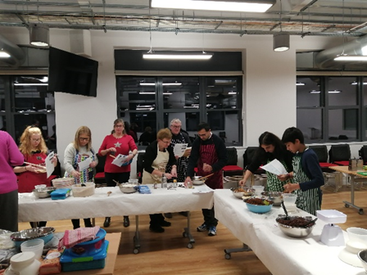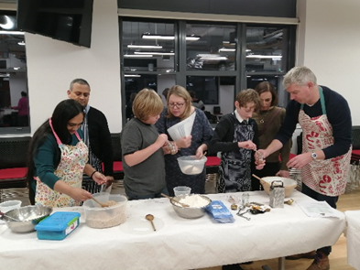
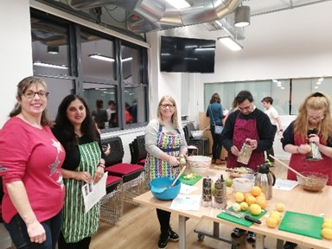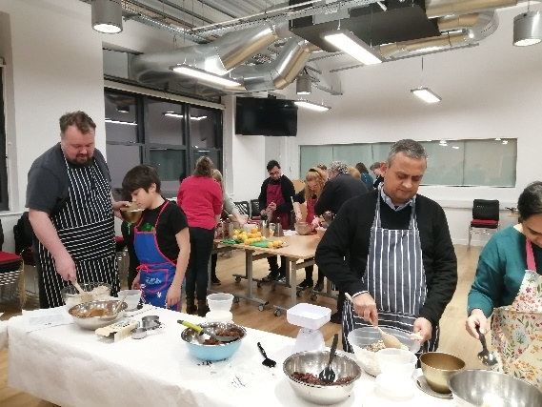

Re-Gifting Appeal – Raising Funds from Unwanted Christmas Presents
Our first re-gifting appeal last Christmas was very successful, thank you to all those who donated gifts. Many of these were put to good use in raffles throughout this year helping to raise valuable funds.
We are running the appeal again this year and would be grateful for your donations please. Don’t hide unwanted or unsuitable Christmas presents in the cupboard. A gift that leaves you uninspired may well be a delight to someone else, and the FoS will make good use of these at our fundraising events throughout the year. The Friends of School will have a box in school reception during the 1st week back after Christmas next term, from 6th – 10th January. Please donate any unwanted gifts by placing them in this box. Thank you in advance for your support.
Additionally, if you have your own business, or work for an organisation that supports local charities and would be willing to donate a raffle or auction prize, we would be very grateful. Please email info@friendsofwbgs.org

Second-Hand Uniform Shop
The uniform shop run by FoS continues to offer a valuable service to parents and we are always grateful for donations of clean, good quality uniform and sports kit that your son has outgrown or no longer needs. We are moving into a brand new, bigger shop in January! Find us in the Cloisters, under the arches off the quad, next to the James Theatre. Opening hours will remain the same: every Wednesday 3.15-4.30pm and the first Saturday of each half-term (next one 9th January 10am-12 noon).
Due to people’s work commitments we need another 1 or 2 volunteers to run the shop on a Wednesday. We have a small group of helpers who man the shop on a rota basis and so you don’t need to commit to every week. If you are able to help out after school on a Wednesday please do get in touch at info@friendsofwbgs.org.

Family Draw – this terms’ winner is Joanne Foley, number 34.

Next Event – Quiz Night – 7th March
A big thank you to everyone who has supported our events and fundraising activities this term, we look forward to seeing you at our next event – the annual Quiz night on 7th March. This is always a great evening so why not get a group of friends together to test your knowledge and have fun whilst raising valuable funds for the school. Tickets will be on sale from early January – look out for details.

Wishing you and your families a restful and happy festive season.
The Friends of School
www.friendsofwbgs.org

